Lab 6 – 7400 and CD4000 Series Integrated Circuits

CE-3101/021 Digital Elex. and Comp. Interfacing

By:

Andrew Iliescu

5-2-2020

**Abstract:**

The ability to rapidly simulate circuits and make changes on the fly is an invaluable tool that has allowed us to analyze circuits rapidly and effectively. This is because of programs like Waveform and the Analog Discovery Kit which allow us to create circuits on a breadboard and then analyze their behavior on a computer. In this lab we are implementing multiple circuit logic inverters in order to gather data as to how each of the inverters behave. This allows us to better understand the benefits and drawbacks of using each of these inverters as well as the applications which best warrant using one of these specific types of inverters. These inverters include the CD4069, 74LS04, 74HC04, 74HCT04.

**Methods:**

Figure 1: Circuit diagram, taken from Ms.Varnell’s CE3101 Lab 6 document

The circuit in figure 1 shows the general layout of how we will be setting up the circuit to test each of the inverters with the Analog Discovery Kit and the Waveforms program. Then we passed in a voltage and measured the output against the input. This data allows us to distinguish certain values like the voltage output high (VOH), voltage output low (VOL), voltage input high (VIH), and voltage input low (VIL). These graphs also allow us to calculate other quantities like the logic-high noise margin (NMH), logic-low noise margin (NML), output propagation time high-low (TPHL), output propagation time high-low (TPLH), output rise time from low to high voltage (Tr), output fall time from high to low voltage and (Tf). All of these values are presented in a table shown in figure 2.

**Results:**

After conducting the lab, we were able to obtain the data for the input and output voltage values for each inverter circuits. We were able to output the data from the lab into excel in order to do out analysis. To get the voltage’s inputs and outputs highs and lows values we graphed the data and made a visual observation as to where the slope is negative one. This was done because there was too much noise that interfered and made it too challenging to get a more accurate reading. The noise margins where then calculated using these voltage values. These estimates are more than just guess work; they are educated guesses made my analyzing the excel graphs shown in figures 3-10.

|  |  |  |  |  |
| --- | --- | --- | --- | --- |
| **Parameter** | **CF4069** | **74LS04** | **74HC04** | **74HCT04** |
| **Test Load** | C= 50pF  R = 200k | C = 15pF  No R | C = 50pF  No R | C = 50pF  No R |
| **VOH** | 4.9V | 2.7V | 4.9V | 4.9V |
| **VIL** | 1.2V | 500mV | 1.5V | 1.2V |
| **VIH** | 3.8V | 1.5V | 3.6V | 2.2V |
| **VOL** | 100mV | 250mV | 250mV | 200mV |
| **NMH** | 1.1V | 1.2V | 1.3V | 2.6V |
| **NML** | 1.1V | 250mV | 1.25V | 1V |
| **TPHL** | 75ns | 15ns | 25ns | 30ns |
| **TPLH** | 65ns | 10ns | 20ns | 25ns |
| **Tr** | 15ns | 20ns | 15ns | 15ns |
| **Tf** | 20ns | 25ns | 20ns | 25ns |

Figure 2: Table from measured values from all of the inverter circuits

Figure 3: Graph of the CF4069 inverter from channel 2 data

Figure 4: Graph of the CF4069 inverter using the derivative of voltage from channel 2 data

Figure 5: Graph of the 74LS04 inverter from channel 2 data

Figure 6: Graph of the 74LS04 inverter using the derivative of voltage from channel 2 data

Figure 7: Graph of the 74HC04 inverter from channel 2 data

Figure 8: Graph of the 74HC04 inverter using the derivative of voltage from channel 2 data

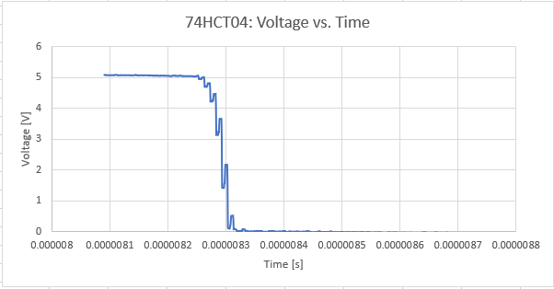

Figure 9: Graph of the 74HCT04 inverter from channel 2 data

Figure 10: Graph of the 74HCT04 inverter using the derivative of voltage from channel 2 data

Now in order to get the time measurements for the table, we used the Waveforms graphs (figures 11-14) to show both the input and output and from there we went ahead and grabbed the excel data in order to perform the necessary calculations. For the time propagation values we got the points for when the output was roughly at half of its height drop and the input at roughly the same point. From there we calculated the difference between the output and input and arrived at our result. The difference in time for the rising and falling voltages was calculated by looking at the x-axis which represented time and see how long it would take each inverter chip to go from either 90%-10% or vice versa.

Figure 11: Waveforms pulse to measure time propagation and change in time for CD4069 chip

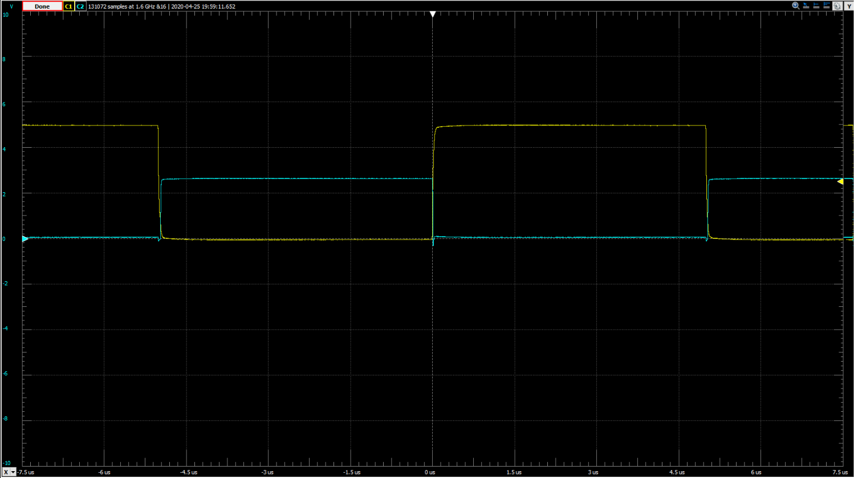

Figure 12: Waveforms pulse to measure time propagation and change in time for 74LS04 chip

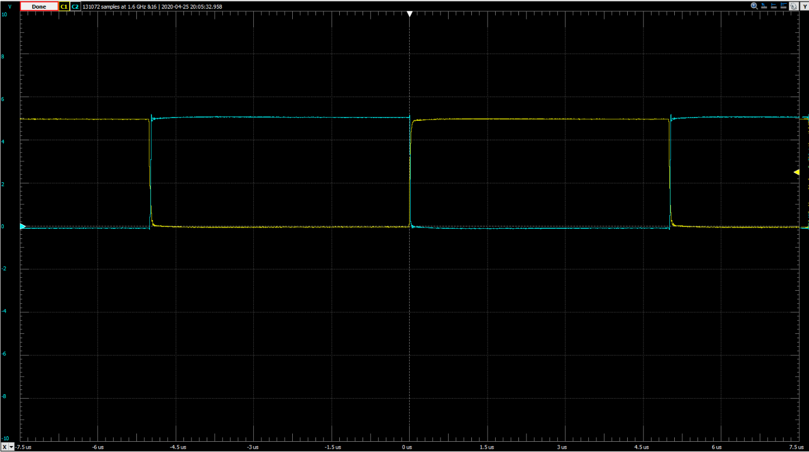

Figure 13: Waveforms pulse to measure time propagation and change in time for 74HC04 chip

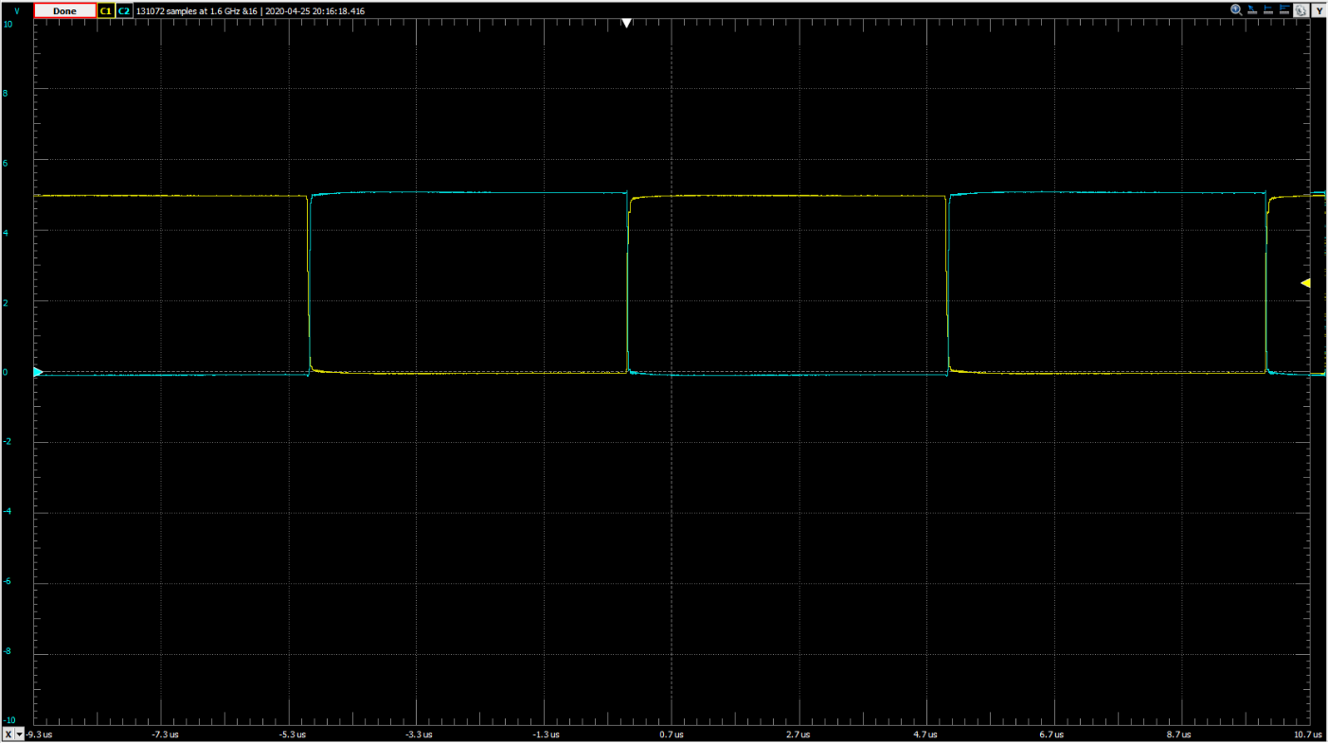

Figure 14: Waveforms pulse to measure time propagation and change in time for 74HCT04 chip

**Summary:**

After conducting this lab and going through all of the data, the most important takeaways are as follows: each inverter chip while similar to the others behaves in a unique way that makes it more useful in certain applications that others, and by looking at the input and out voltage as well as the pulses of those voltages, we are able to identify and analyze the behaviors of these inverter chips.

**Appendix:**

No items to present.